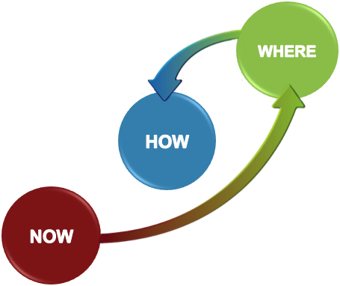
One Page Plan
Project title:  Date:  Version:  Project Leader: |  | Notes

NOW |  | WHERE | What does success look like (measure | By.. (date)
 |  | Short-term
 |  | Longer-term (The Ultimate WHERE)

How Strategies for getting there… (the approach) |  | Actions | Who? | By (date)

The team…
Role | Responsibility (who?) | Accountable for…
Soundfair
Creative Commons: Attribution-NonCommercial 3.0 Australia (CC BY-NC 3.0 AU)

